Exp No:16
SERIAL INTERRUPT USING UART (KEYBOARD INPUT) IN KEIL
Code:
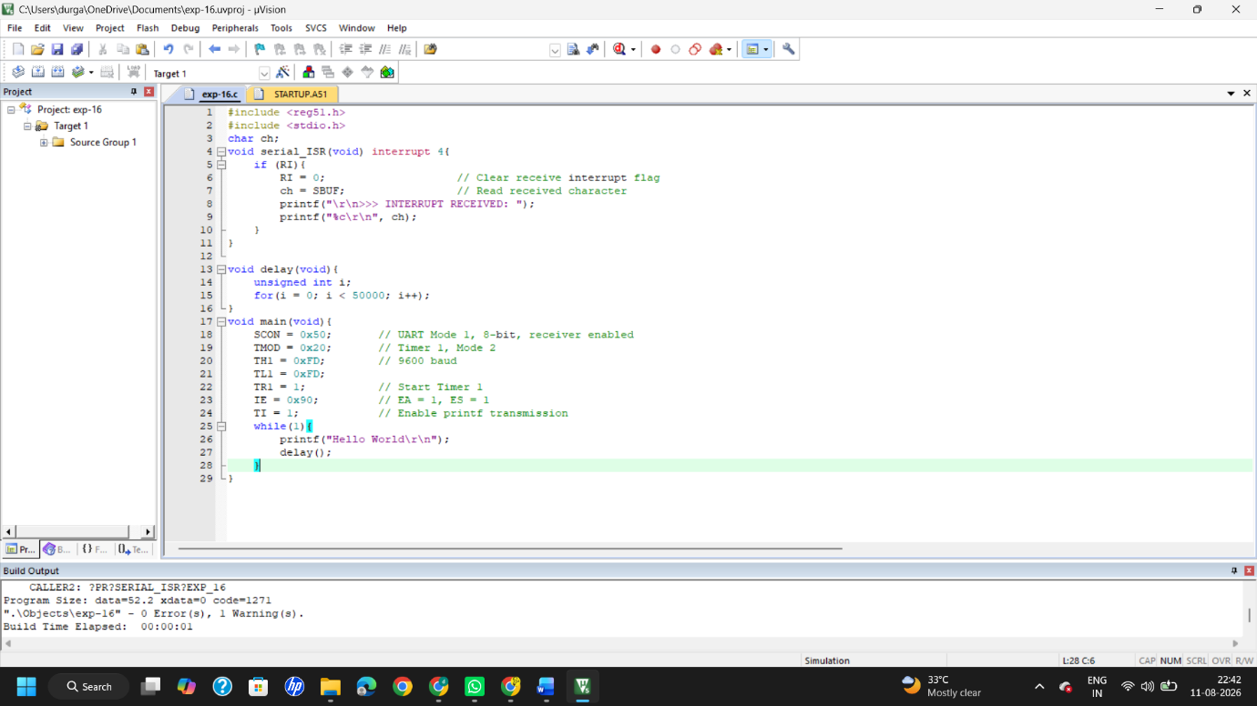
Output:
Displaying a Message:
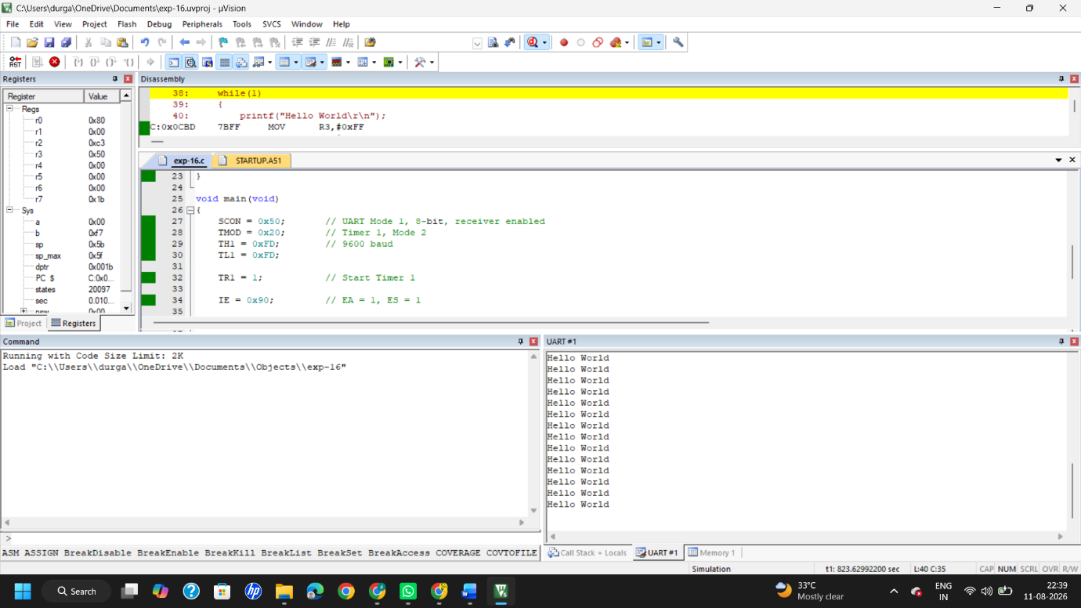
During interruption:
